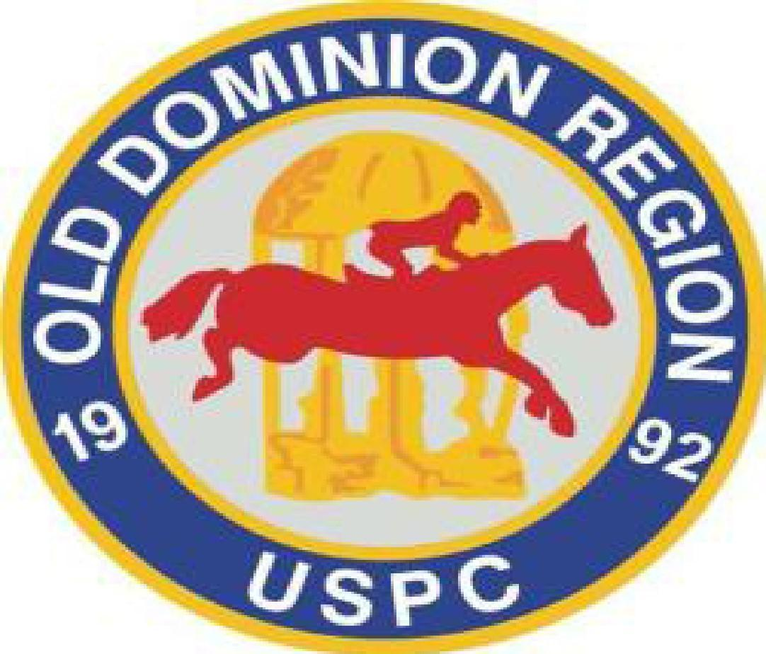
2024 GAMES RALLY FACT SHEET
Saturday May 4th
VIRGINIA POLO CENTER
1082 Forest Lodge Drive, Charlottesville, VA 22903

Mountain Skyline Pony Club is pleased to host the 2024 Old Dominion Region Games Rally.
Rally Organizer: Hannah Orsagh, MSPC Secretary Cell: 646-436-4362
Email: mountainskylineponyclub@gmail.com
CLOSING DATE: Saturday April 20, 2024
Excel entry forms must be received by email by the Rally Secretary (mountainskylineponyclub@gmail.com) by April 20, 2024. Checks made payable to ODRPC must be mailed promptly to Rally Treasurer/Alex Huebner, RR1 Box 694, 37 Grassy Overlook, Roseland, VA 22967
(Please note, incomplete entries will be assessed a $25 fee that must be paid prior to the member competing in the rally. The only exception to “missing paperwork” (incomplete entry) will be a current Coggins. A current Coggins must be received by the Rally Secretary prior to the start of the rally. No horse will be allowed to compete without a current negative Coggins on file with the rally secretary.)
RULES: 2024 GAMES RULEBOOK and all current Addenda
2024 GAMES Annual Newsletter
2024 USPC HORSE MANAGEMENT RULEBOOK and all current Addenda
2024 HORSE MANAGEMENT Annual Newsletter
(All Available on USPC web site: www.ponyclub.org)
This will be a qualifying Games Rally for the 2024 USPC Championships. Games Rally is a fun first rally for new members. There will be a Rising Star Division if entries permit. Non-pony club members are welcome to participate in the Rally.
FEES: $400.00/5 man team ~ $320.00/4 man team ~ $240.00/3 man team ~ $80.00/individual rider ~ No fee for stable manager/C-level adviser.
REFUNDS: Refund of the entry fee (minus a $25 office fee) will only be given for a sick/lame horse or rider, or a family emergency, up to 1 week prior to the rally. A vet or doctor’s note, or documentation of the emergency must be provided to the Rally Secretary when requesting the refund. All refund requests must be submitted along with the required documentation to Rally Secretary by Saturday April 27th
STALLS: This is a one-day trailer rally. Tack rooms will be at the trailers.
Please make a note if you would like a stall. Stalls are limited and assigned on a first come, first served basis.
Stalls are $30 per night and are available Friday night.

BEDDING: If you have reserved a stall, you will need to supply your own bedding.

FEED/HAY STORAGE: Trailer Rally.
LODGING: There are no specific rooms blocked, however recommended options near the facility are:

- Holiday Inn Charlottesville-Monticello, 1200 5th Street Ext, Charlottesville, VA 22902
- Sleep Inn & Suites, 1185 5th Street SW, Charlottesville, VA 22902

LUNCH: TBA

VOLUNTEERS: Each Team must list a minimum of one Volunteer per mounted competitor. Volunteers must be listed on the entry form.

TEAM COMPOSITION:
- Teams may consist of 4 or 5 riders with or without a Stable Manager. Please see the latest rules concerning team composition and extra mounts.
- Coaches are not required but are permitted.
- Coaches cannot be the chaperone.
- The Rally Organizer will put together Scramble Teams.

DCs must ensure that their club members are safe and comfortable at the levels they will be competing. No changes can be made after the closing date.
DIVISIONS: The following will be offered if participation allows:
*** Please note that divisions may be combined for riding purposes pending the number of teams. ***.
Walk-Trot/Rising Stars: Non-qualifying for members ages under 10 who will walk and trot only. Teams of 2 to 5 riders accompanied by a C level member or qualified adult with C-level experience.

Junior: 4 or 5 riders, 10-17 years of age as of 1/1/24
Senior: 4 or 5 riders, 18-adult years of age as of 1/1/24
Advanced Pairs: 2 riders, C-1 FL, 18-adult years of age as of 1/1/24

Please see the following information for Champs Qualifications.

Modified Novice Team D-2 DR/EV/Flat/HSE 10-14
Novice Team C-1 DR/EV/Flat/HSE 12-14
Modified Junior Team D-2 DR/EV/Flat/HSE 15-17
Junior Team C-1 DR/EV/Flat/HSE 15-17
Modified Senior Pairs D-2 DR/EV/Flat/HSE 18+
******Please note it is our goal to get everyone to champs, if possible, in your discipline of choice. However, teams that have qualified and are representing their region will have first priority. The Games Committee will assist in finding a team for the scramblers however, there is no guarantee a scrambler will have a team. Please make every effort to create a team*********

HORSE INSPECTIONS (JOGS): Horse inspections are required at all mounted rallies. Competitors must be familiar with the rules and the procedure for inspections and the competitor, and their horses must know how to jog. Refer to the HM Handbook.
MEDICAL CARDS AND ARMBANDS/BRACELETS: All rally participants are required to have a medical armband with a completed USPC Medical Card in place when they check in at the Rally Show Office and for the duration of the rally. A medical bracelet is acceptable, but must meet all USPC informational requirements as stated in the HM Handbook. No packet will be handed out to a participant who does not have the medical arm band and USPC Medical Card in place.

What if a member forgets the Medical Card at home or loses it during the rally? It is suggested that each competitor pack an extra complete Medical Card in their luggage, especially if a parent is not going to be on the rally grounds. It is also suggested that an extra medical armband and a blank Medical Card be included in each team's rally utility kit. Rally Organizers will have blank medical cards available in the show office.
EMERGENCY MEDICAL TREATMENT OF MOUNTS: Please be advised that in the case of the need for evaluation and/or treatment of a mount by a licensed veterinarian the evaluation must be at the decision of the owner of the horse or as agreed on by the owner of the horse and the individual who is leasing/using the mount for this activity. The representatives of the Old Dominion Region will not assume any responsibility in this decision but will assist the owner or participant in seeking treatment if that should be the decision of the owner of the mount as indicated by the individual who is using that mount for the activity. All expenses that may result from any such evaluation or treatment are at the expense of the owner or individual using the mount.

POSSIBLE GAMES LIST: Please ensure teams are familiar with the rules.

Ball and Bucket | Needle and Thread
Ball and Cone | Pony Club Race
Ball and Raquet | Quoits and Cone
Balloon Race | Rubber Ducky
Bending Race | Stepping Stone
Bottle Race | Stick Pegging
Canadian Race | Sword Race
Five Flag | Three Mug
Five Mug | Two Flag
Hi-Lo | Windsor Castle
Hula Hoop
Litter Race
Mug Shuffle
Tie Breaker: Ball and Cone
Games are played pending an allowable schedule. Games list is subject to change. Additional Games could be played or fewer games could be played. There will be no less than 8 Games played per division.
AWARDS: Horse Management Teams (1st – number of teams entered)
Overall Teams (1st - number of teams entered)
High Point Individual combined riding and HM in each division

TENTATIVE SCHEDULE: Friday May 3rd: Competitors may move in Friday afternoon. STALLS FOR THIS NIGHT ARE NOT INCLUDED IN ENTRY FEE and must be reserved in advance. Please be sure to include the cost of any stall night ($30) in your entry. Check in with the Rally Organizer and/or Secretary upon arrival.

 | Saturday May 4th 2024
Time | Activity
6:00 AM | Barns open, begin move in/set up
8:00 AM | Competitor Briefing followed by Parent Briefing at Clubhouse
9:20 AM | Weights, Measures, Jogs - All participants
10:30 AM | Turnout Inspections begin
11:00 AM | Games begin (Walk/Trot)
3:00 PM | Second Session
TBA | Awards Ceremony at conclusion of Turn Back Inspection, final scoring and equipment breakdown
PM | Departure

Notes to DC when filling out entry:
- Be sure to complete an interactive entry form for each team, partial team or individual
- Remember – there are no changes in divisions after the closing date
EACH ENTRY FORM MUST BE ACCOMPANIED BY THE FOLLOWING:
- Electronic interactive entry form (including volunteer section) sent to Rally Secretary by closing date of April 20, 2024
- Current Negative Coggins for Each Pony/Horse (name on Coggins MUST match entry form). Coggins may be scanned and sent electronically to the Rally Secretary or hard copy mailed in advance.
- Page 1 of the Team Chaperone Form sent electronically– 1 per team, or 1 per individual competitor
- Note the name of the Coach on the interactive entry form. All coaches must attend the coach briefing and will be required to sign the coaches form at this meeting and will then get their “official” coaching badge. Coaches are not required.
- Check or PayPal payable to ODRPC in the proper amount for entry fees and any stall.
OLD DOMINION REGION PONY CLUBS
INDIVIDUAL RALLY RELEASE/EQUINE RELEASE for Non Pony Club Participants
Name: D.O.B:
Address:
City/State: Zip:
Email:
Telephone:
It is agreed that the Organizing Committee of the Old Dominion Region Games Rally, its officials, the Region, USPC, Virginia Polo Center and employees thereof, will not be held liable for any loss, accident, injury, illness to horses, riders, attendants, spectators or any other person, corporation or property whatsoever. I hereby give permission for my child to participate under this agreement.

COMPETITIVE RALLY RELEASE: My child and I have read and understand the policies and regulations governing the United States Pony Clubs, Inc., and specifically the current USPC Handbook and Rules for Games Competition 2024 and agree to abide by these rules at the Old Dominion Region Games Rally on May 4th 2024.
CODE OF CONDUCT: USPC is proud of its reputation for good sportsmanship, horsemanship, teamwork, and well-behaved members. The ODRPC and the organizers and officials of this rally expect appropriate behavior from all competitors, parents and others participating in this activity. Inappropriate behavior is, but not limited to:
- Possession, use or distribution of any illegal drugs or alcohol
- Assault
- Profanity, vulgar language or gestures
- Harassment – using words or actions that intimidate, threaten or persecute others
- Cheating
- Abusing a horse
Any member or parent not conforming to the Code of Conduct is subject to the following actions:
1) The officials of the competition may immediately suspend or expel an individual from the competition upon consulting with the Grounds Jury
Competitor’s Signature/Date:
Parent/Guardian Signature/Date
Location Details & Driving Directions
Virginia Polo Center is located at 1082 Forest Lodge Drive, Charlottesville, VA 22903
From East / Richmond
Take I-64 West. From I-64 take the VA-631 exit- exit 120 5th Street / Charlottesville. Turn Left onto 5th ST Ext. 5th St Ext becomes Old Lynchburg Road, go 1.7 miles. Turn left onto Forest Lodge Lane.
From West / Harrisburg
Take I-64 East. From I-64 take the VA-631 exit- exit 120 5th Street / Charlottesville. Turn Right onto 5th ST Ext. 5th St Ext becomes Old Lynchburg Road, go 1.7 miles. Turn left onto Forest Lodge Lane.
From North / Washington DC
Take 29 South. Turn right onto 250 West, then exit onto I-64 East. From I-64 take the VA-631 exit- exit 120 5th Street / Charlottesville. Turn Right onto 5th ST Ext. 5th St Ext becomes Old Lynchburg Road, go 1.7 miles. Turn left onto Forest Lodge Lane.
From points South / Lynchburg
Take 29 N. Turn right onto I-64 East. From I-64 take the VA-631 exit- exit 120 5th Street / Charlottesville. Turn Right onto 5th ST Ext. 5th St Ext becomes Old Lynchburg Road, go 1.7 miles. Turn left onto Forest Lodge Lane.

